Independent Book Project Instructions
The main purpose of the Book Projects is to get you reading and enthusiastic about reading, as well as exploring different genres of books. I will be looking for overall understanding of the book, as well as, evidence that you have read the book.
Every month, you will choose a new book to read for your independent reading project. Once you have completed a particular free-choice project, you may not repeat the same choice for future projects. You will be given a choice menu and some monthly options as well. Reading different genres of books is encouraged.
September: FREE CHOICE
Book choice has to at least be on a 5th grade reading level (it can be higher if appropriate)

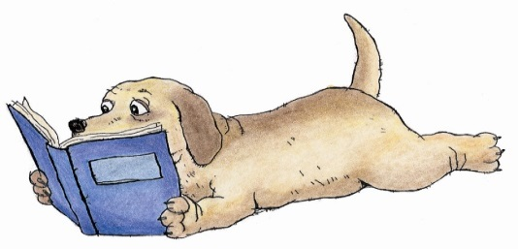
DUE DATE: Thursday, Sept. 28th

- If a book is too difficult/easy, or you cannot find interest in it, you may exchange the book and choose a different one within the first week of the project. Books can be chosen from our classroom library, a library book, and/or a book from home.
- If you have any questions on how to complete the projects, please let me know and ask me so I can explain the details and expectations.
- Be creative with the materials you will use! You can use crafts, markers, paints, construction paper, poster board, clipart, internet pictures, real pictures, or hand-drawn/colored pictures.
- You can type information for any project, but remember…all the information should be written and presented in your own words. No Plagiarism is permitted!
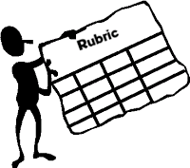
You will be graded on the following:
- Content, Accuracy, and Relevance
- Graphics (photos, pictures, etc.)
- Attractiveness/Creativity/Neatness
- Spelling/Grammar/Mechanics
- Presentation and Preparation…on time!

